**Android**

**Project Proposal**

**Spring 2019**

**Group 2**

**Project Name:** Attendance Assist

**Team members:** Gangadhar Adusumalli

Preetham potu

Vennela Cheekoti

Sathwika Gone

**Aim:**

This application is mainly used for student to add courses, class schedule, enter the attendance and student can view the class schedule, can set the time so that he can get the notification on his class time.

**Modules:**

1. **Home page:**

When student click on the plus button at bottom he will get add course option. Student can find calendar icon, courses icon, prediction icon, and Time Table icon. On the right side of the page user can view a menu with settings option.

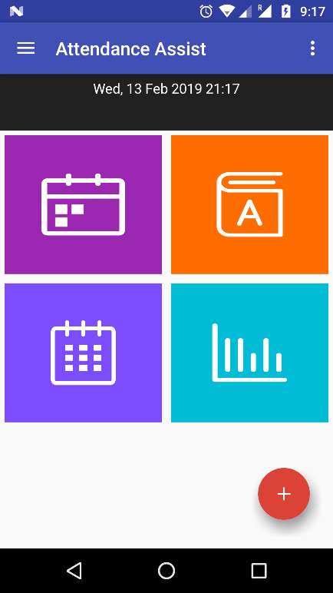

1. **Add course page:**

To add course student should enter course name, weekday, start time and end time in this page.

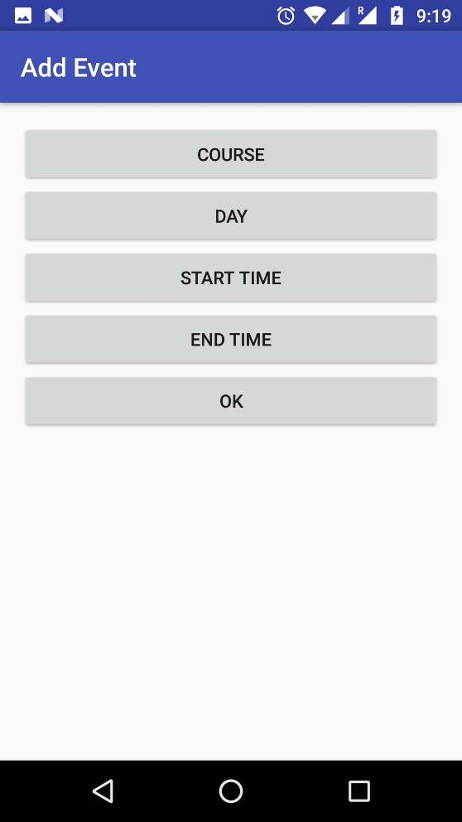

1. **Time Table :**

When student click on the schedule icon on the home page he will redirect to Time Table page where he can select a particular day of weak so that he/she can view the schedule for all courses on that day.

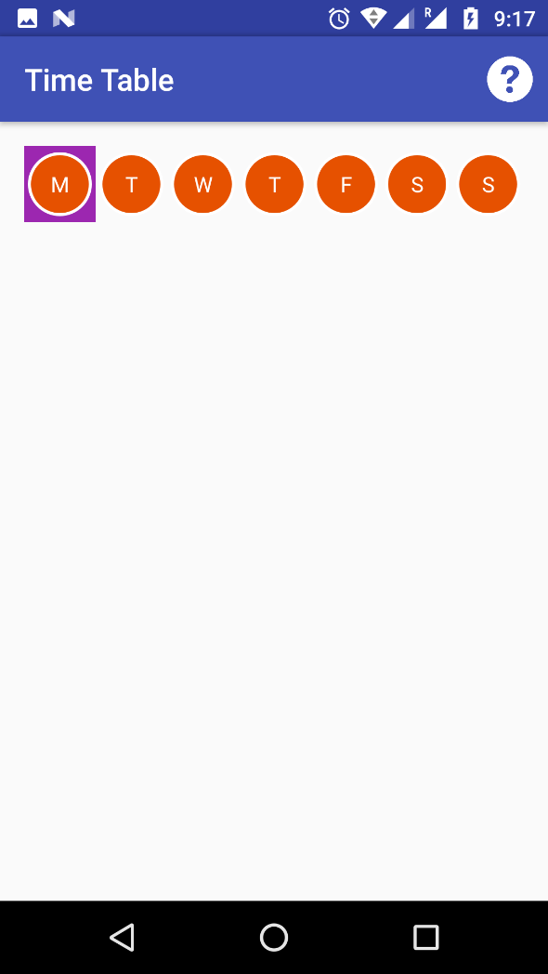

1. **Calendar:**

When student click on the calendar icon on the home page he/she will redirect to the calendar page where student can select the course and the date to know timings of the course and can mark present or absent to that class.

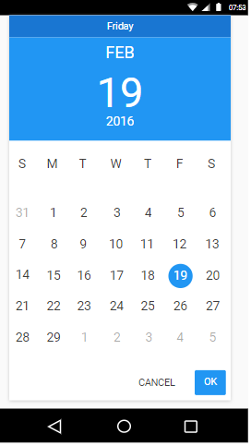

1. **Prediction :**

When user click on the prediction icon on the home page he/she can add the number of classes attended and missed to get the attendance percentage.

1. **Courses:**

When the user click on the course icon on the home page he will redirect to courses page where he/she can view the courses. When he selects particular course he get the classes attended, number of classes he/she missed, and attendance percentage.

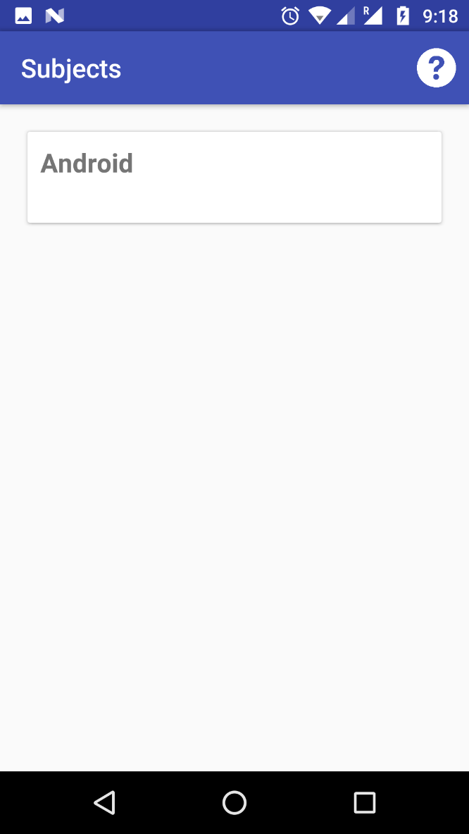

1. **Settings page:**

When the user selects settings option on the home page he/she redirects to settings page where student can set the minimum attendance percentage and set the time to get notification and reminder for classes.

**Technical Aspects:**

In Frontend we are planning to create 5-8 screens and in Backend we will have database named SQLite where all the course and their schedule will be stored.

**Risky components:**

* We are not using any outside API.
* In our application we are going to implement alarm manager, notification manager, calendar, floating buttons, appbar and splash screen.
* Required services: Databases.

Github repo link:

<https://github.com/vennela-cheekoti/BearcatAttendanceTracker>

ER Diagram:

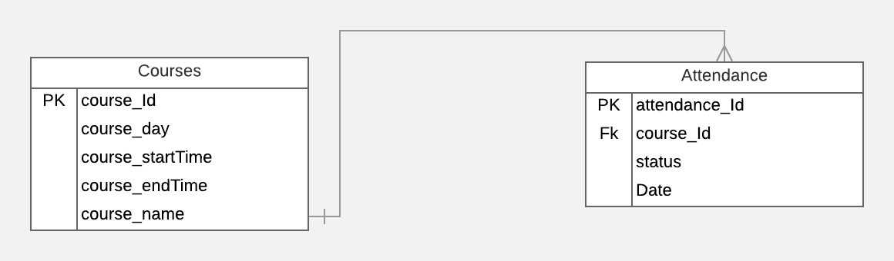

App logo:



App Name: BearcatAttendanceTracker